Polytan sports surfaces for a new "elite sports school" in Munich
Learning with Olympic flair
If athletes from Munich are competing for Olympic gold, silver and bronze medals in a few years’ time, it may be that they attended the Gymnasium München-Nord school: this new educational establishment in the Milbertshofen-Am Hart district has been one of 43 "elite sports schools" across Germany since July 2016. The sporting disciplines they focus on are volleyball, judo, basketball, archery, athletics, swimming, synchronised swimming, short track (speed skating), table tennis, football and trampolining, all of which are funded in partnership with sports federations. Many sports facilities provide training to Olympic standards in order to meet the requirements of an elite sports school. Polytan was in on the action when the outdoor facilities were installed: all the areas for track and field athletics – including a 110-metre sprint track – and two basketball courts were covered with synthetic surfaces made by the Burgheim-based sports surface specialist. Soft-impact surfaces from Polytan were installed on the fitness trail and beneath the monkey bars and climbing frame.
The four-form entry school was constructed by the building directorate of the Bavarian capital and provides places for up to 1,000 girls and boys and 100 teachers, with special measures being taken to develop the sports skills of one class from every year group above middle school age. The school was designed by architects from the firm h4a Gessert + Randecker Generalplaner, who managed to combine the high demands of teaching and sport in a ground-breaking style of architecture. Their plan is an exemplary execution of the Munich learning house concept and also provides premises flooded with light and ultra-modern equipment.
Light as an element of architectural design
The centrepiece of the school is the three-storey main building with a virtually unsupported assembly hall of around 1,000 square metres. A platform and seating areas make this a very pleasant public space, although this is also down to the chosen materials of wood, exposed concrete and glass, a harmonious combination found throughout the school. Large windows and walls with triple glazing, skylights and glazed courtyards produce a bright and friendly atmosphere everywhere.
The ground floor of the main building also accommodates a cafeteria with a kitchen, a multi-purpose room and a library. The top two floors are where the offices and classrooms are situated.
Connected to the south of the main building are three learning houses in which several year groups form "clusters". Each of the two-storey learning houses has a central forum with a courtyard around which are grouped classrooms, staff rooms and sanitary facilities. The main building and learning houses are arranged in a row, allowing the four structures to be linked by a wide thoroughfare.
In the north, a triple-purpose hall built partly below ground level and with seating for almost 200 spectators backs onto the main building – with a ceiling height of 10 metres, it is suitable for matches in the German volleyball Bundesliga. A 15 x 15 m unsupported judo hall in the basement is another one of the school's attractions and has a gym and weights room to complement the facilities for indoor physical education.
The outdoor sports facilities were designed and executed by the Eichstätt-based architects Hackl Hofmann Landschaftsarchitekten commissioned by the Munich building directorate. They also provide optimal conditions for the demands of elite sport, including two basketball courts, a high jump, long jump and shot-put area, a 45-metre-long bouldering wall, a 110-metre running track and a real grass football pitch. The outdoor installations are rounded off by a fitness trail, monkey bars and a climbing frame.
100 per cent fit for competition – the synthetic surface Rekortan M
When it came to the 110 metre six-lane sprint track, the landscape architects opted for the water-impermeable Rekortan M synthetic surface by Polytan in classic running track red. This is a winner in terms of its good acceleration and tread elasticity, optimal shock absorbency and sports medical values. The fact that the granules are interspersed with visible tips means that it is ideally suited to spikes. Poured in-situ, this surface has also proven itself on the international stage by hosting numerous IAAF Diamond League athletics meetings, including many world bests and world records.
PolyPlay S – the durable all-rounder among synthetic surfaces
The PolyPlay S synthetic surface from Polytan was installed on all the outdoor sports facilities requiring a smooth but non-slip top layer with very good ball bounce behaviour. The two basketball courts were finished in the same brick red as the running track, whilst the high jump, long jump and shot-put areas stand out in an elegant light grey. What is more, the PolyPlay S system is water-permeable, so the surfaces dry very quickly and can be used in all weathers throughout the year. As the two-course sports surface is durable and easy to maintain, it is ideal for heavily used school sports facilities.
Soft-impact PolyPlay FS – the shock-absorbing synthetic surface
The PolyPlay FS soft-impact surface in light grey was installed in and around the areas of the fitness trail, the monkey bars, the climbing frame and the 45-metre-long bouldering wall – and duly attuned to the required drop heights of the equipment. The system consists of two layers: the top layer is 15 mm thick and manufactured from high-grade, completely newly produced EPDM granules (rubber). The second, supporting layer is made of recycled materials and provides the requisite elasticity. The thickness of the base layer varies between 30 and 115 mm, depending on the critical drop height. There are soft-impact surfaces up to a drop height of 3 m, with a handrail required by law above this.
www.polytan.com

Construction site sign
- Client: City of Munich, Department of Education and Sport (Landeshauptstadt München, Referat für Bildung und Sport)
- Project management: City of Munich, Building Directorate (Structural Engineering)
- Design and execution planning: h4a Gessert + Randecker
Generalplaner, Stuttgart / Munich
- Site management: köhler architekten + beratende ingenieure, Gauting
- Design and execution planning, site management, outdoor facilities: Hackl Hofmann Landschaftsarchitekten, Eichstätt
- Construction period: June 2014 to July 2016
- Useful area: approx. 11,000 m²
- Gross floor area: 18,500 m²
- Gross volume: approx. 86,300 m²
Sports areas with Polytan
- 2x multipurpose pitch: PolyPlay S synthetic surface in brick red
- High jump, long jump, shot-put areas: PolyPlay S synthetic surface in light grey
- 110 m track with 6 lanes: Rekortan M synthetic surface in brick red
- Soft-impact surface with drop height of 3.00 m under the climbing wall: PolyPlay S synthetic surface in light grey
- Monkey bars and climbing frame, drop height 3 m: PolyPlay S synthetic surface in light grey
- Fitness equipment, drop height 2.00 m: PolyPlay S synthetic surface in light grey
- Three courtyards with objets d'art: PolyPlay S synthetic surface in orange

Captions:
Picture credits: Tobias Müller / Polytan
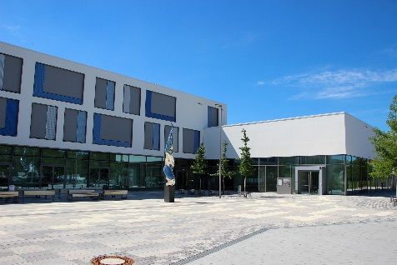 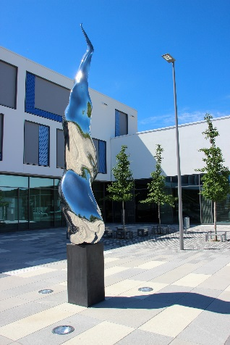
Polytan_Gym-München-Nord_01+02.jpg
Standing outside the entrance to the new "elite sports school" in the Munich district of Milbertshofen-Am Hart is an Olympic torch – the work of art is entitled "Feuer und Flamme" (Fire and Flame) and is by Bruno Wank from Munich.
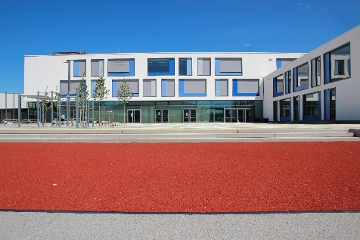 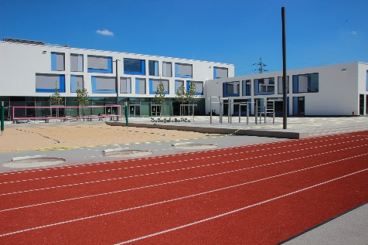
Polytan_Gym-München-Nord_03+04.jpg
The outdoor facilities behind the main building include a 110-metre sprint track, the playground and a beach volleyball court. The latter can also be used for the shot-put.
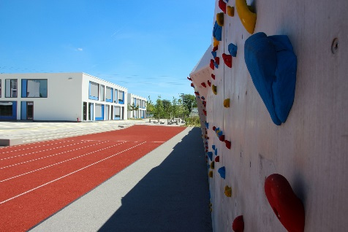 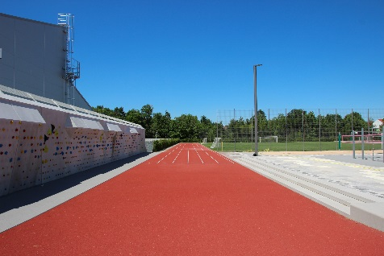
Polytan_Gym-München-Nord_05a_5b.jpg
Another highlight of the school is a 45-metre-long bouldering wall running alongside the brick-red running track.
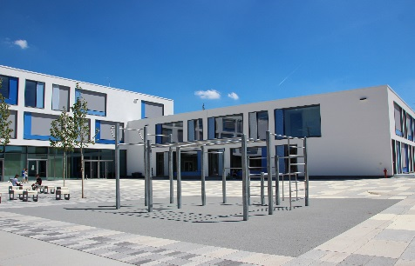 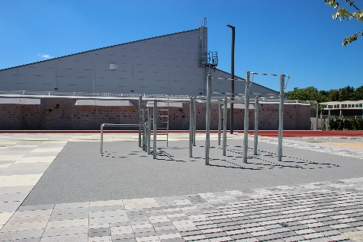Polytan_Gym-München-Nord_06a + 06b.jpg
The monkey bars and climbing frame are integrated into the playground. With a maximum drop height of 3 metres, the PolyPlay FS soft-impact surface protects against serious injury. The light grey shade of the synthetic surface blends in beautifully with the modern appearance of the school.
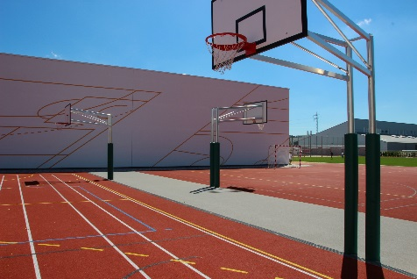 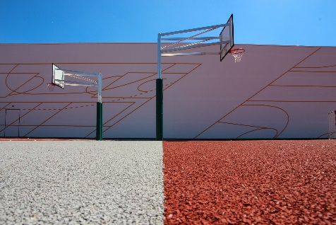
Polytan_Gym-München-Nord_07 + 08.jpg
Two basketball courts round off the sports facilities to the rear of the triple-purpose sports hall. The synthetic surface chosen by the planners was the water-permeable PolyPlay S – a universally usable sports surface with a smooth top layer and very good ball bounce behaviour.
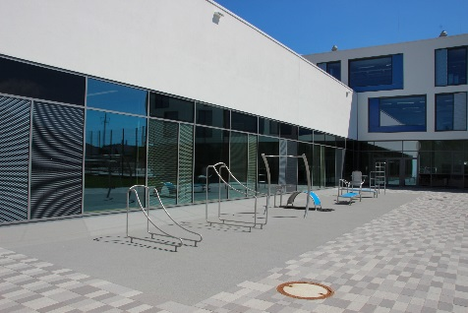 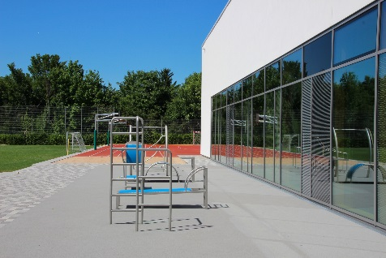
Polytan_Gym-München-Nord_09a + 09b.jpg
The fitness trail in front of the sports hall was covered with the PolyPlay FS soft-impact surface – this light grey surface from Polytan protects athletes from serious injury and is water-permeable.
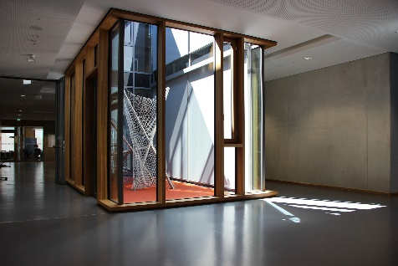 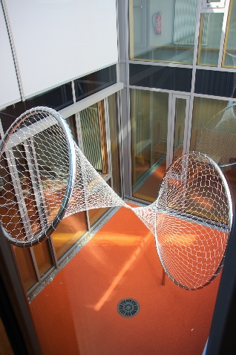
Polyan_Gym-München-Nord_10 + 11.jpg
The objets d'art "Auf die Plätze" (On your marks) by Munich artist Stefan Wischnewski are housed in three inner courtyards. The flooring consists of the PolyPlay S synthetic surface in orange – a shade that changes in intensity depending on the incidence of light.
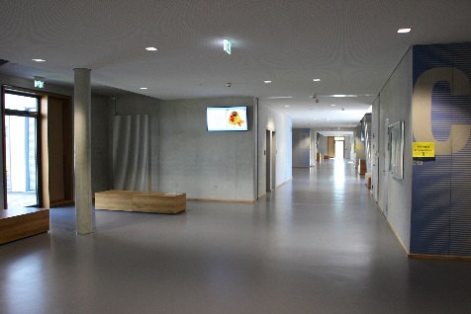
Polyan_Gym-München-Nord_12.jpg
View of the main thoroughfare – a wide passageway and pleasant public space linking the main building and the learning houses.

Polytan GmbH:
To make the optimal surface for sporting success – that has been the ideal pursued by Polytan since 1969. With a constant eye on the latest findings in the field of sports medicine, the specialist in outdoor sports surfaces is continuously refining its synthetic surfaces and synthetic turf systems. Today's synthetic turf pitches not only feel like real grass, for example, but they also have excellent playing qualities. High-quality synthetic surfaces now range from shock-absorbing soft-impact surfaces and multi-functional all-weather pitches all the way to high-speed surfaces for international athletics events. As well as developing, manufacturing and fitting its own sports surfaces, the spectrum of services provided by Polytan also includes line markings, repairs, cleaning and maintenance. All products meet current national and international standards and are duly certified by international sports federations such as FIFA, FIH, World Rugby and IAAF.

Agency contact:
Seifert PR GmbH (GPRA)
Barbara Mäurle
Zettachring 2a
70567 Stuttgart
0711 / 77918-26
barbara.maeurle@seifert-pr.de

Company contact:
Polytan GmbH
Tobias Müller
Gewerbering 3
86666 Burgheim
08432 / 8771
tobias.mueller@polytan.com

