Supporting Athletics in Wales

Welsh Athletics Joins Forces with Polytan to Elevate Athletic Standards in Wales

Welsh Athletics, the governing body for the sport of athletics in Wales, and Polytan, a global leader in sports surfacing, are thrilled to announce their new partnership. This collaboration marks a significant step forward in advancing the quality and accessibility of athletic facilities across Wales.

Welsh Athletics, responsible for the promotion and development of athletics throughout Wales, seeks to harness this partnership to further its mission of nurturing world-class athletes and increasing participation at all levels of the sport. Through initiatives aimed at improving facilities and athlete support, Welsh Athletics is committed to making athletics a cornerstone of community sport across the region.

Polytan, known for its innovation and dedication to sustainable sporting solutions, brings a wealth of expertise and advanced technology to this partnership. As part of the agreement, Polytan will supply cutting-edge sports surfaces to Welsh athletic venues, incorporating environmentally friendly materials and practices.

James Williams, CEO of Welsh Athletics, expressed enthusiasm about the partnership, stating, “We are excited to join hands with Polytan, a leader in athletic surface technology. This partnership aligns perfectly with our vision to elevate the standard of athletics in Wales. By improving our facilities, we can offer our athletes and community the best possible environment to thrive.

We will also be working with Polytan to promote new and innovative solutions for our sport – be it a focus on moving to more sustainable surface materials, or the creation of compact facilities that are more flexible and affordable.“

From Polytan, Ashley Appleby, Sales Manager UK, highlighted the strategic benefits of the collaboration, “Welsh Athletics presents a dynamic platform for Polytan to showcase its commitment to sport and environmental stewardship. We are proud to support Welsh Athletics in their goal to foster talent and promote athletics across Wales. Together, we aim to set new benchmarks in the quality of sports facilities.”

This partnership aims to significantly enhance athletic facilities throughout Wales by upgrading tracks and other facilities with Polytan's cutting-edge sports surfaces, including the innovative Polytan SMART systems. Such improvements are designed to provide Welsh athletes with superior training environments, aiding in their development and enabling them to compete at the highest international levels.
Furthermore, the collaboration emphasizes a strong commitment to sustainability. By integrating Polytan's Green Technology in athletic infrastructure projects, the partnership promotes eco-friendly and sustainable practices in the management of sports facilities, ensuring a greener future for athletic development in Wales.

This partnership between Welsh Athletics and Polytan is set to transform the landscape of athletics in Wales, providing promising athletes with the resources they need to succeed and bringing communities together through sport.

Images:

Polytan Official Partner of Welsh athletics_1

Cardiff International Sports Stadium, revamped in 2019 with Rekortan M in Hertha blue

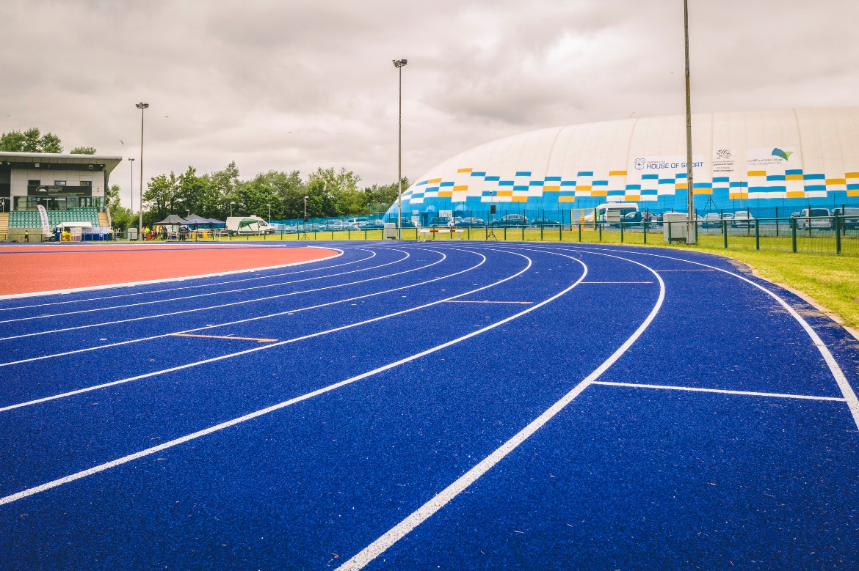

Foto: Polytan GmbH

Polytan Official Partner of Welsh athletics_2

With Polytan SMART, every metric matters—from speed to stride.

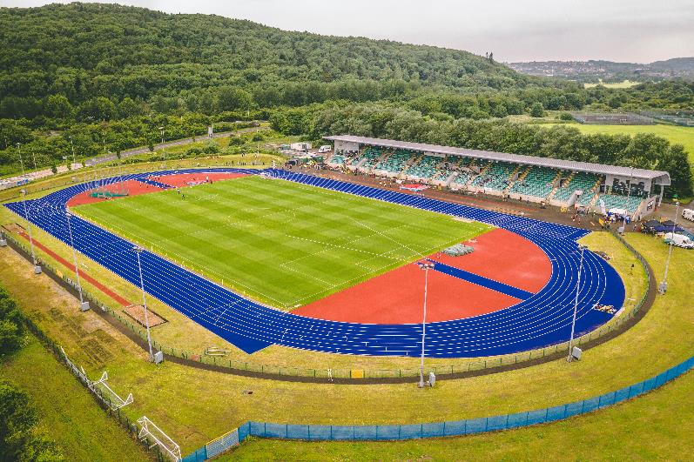

Foto: Polytan GmbH

About Welsh Athletics:

Welsh Athletics is the national governing body for athletics in Wales, dedicated to promoting the sport at all levels from grassroots to elite performance. Committed to fostering talent and increasing participation, Welsh Athletics supports athletes, coaches, and volunteers across various disciplines. With a focus on community engagement and athletic excellence, Welsh Athletics aims to inspire every individual in Wales to participate in athletics, contributing to healthier, active, and successful communities.

Find more information at:

About Polytan:

Providing the optimal surface for athletic success – Polytan has pursued this aim with its sports flooring and artificial turf systems since 1969. And the bonus is that sustainability and environmental compatibility have always been a priority for us here at Polytan. The spectrum ranges from environmentally friendly raw materials and energy conservation during the manufacturing processes to the recycling of the surfaces. In line with its motto of “We make sport. Greener.” Polytan is continuously and effectively improving the future of sports flooring. Polytan’s Green Technology line (GT) is the result of years of research and signals a new generation of state-of-the-art products and processes that combines specialised expertise with the functional and ecological benefits of renewable raw materials and resource-saving technologies.
Polytan’s portfolio is built for disciplines such as football, hockey, rugby, American football, athletics, tennis and multisports, and even offers fall protection. As well as developing, manufacturing and installing sports surfaces, Polytan also offers line painting, repair, cleaning and maintenance as part of its range of services. Polytan provides the largest sports surface installation network in Europe, the Middle East, Asia and the Pacific. All products comply with the current national and international standards, and have all the relevant certifications of international sporting associations, such as FIFA, FIH, World Rugby and World Athletics.

Find more information at: https://www.polytan.com/ und https://wemakesport.polytan.com/.

Company Contact:
Polytan GmbH
Tobias Müller
Gewerbering 3
86666 Burgheim
08432 / 87-71
tobias.mueller@polytan.com

